**TRYING OUT SOME COMMANDS**

|  |  |
| --- | --- |
| NAME | S.SHANTHAN REDDY |
| ROLL No. | CB.EN.U4CSE19459 |

1. **cmd.exe**

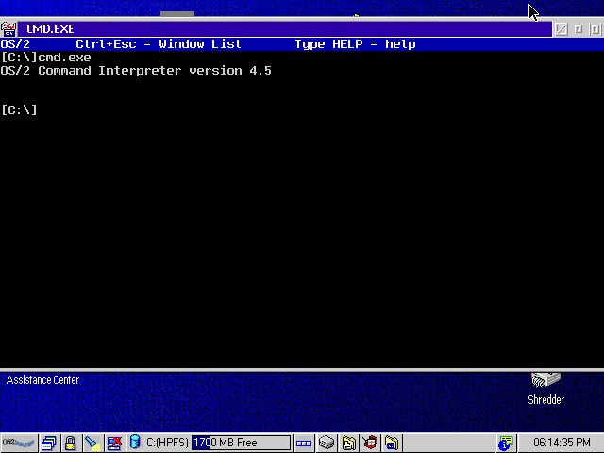

1. **dir**

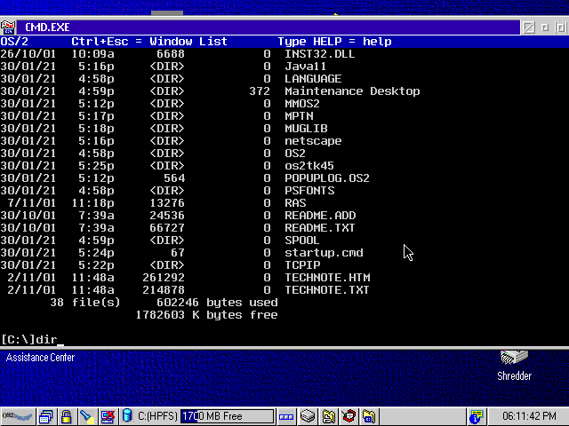

1. **Ifconfig :**

